An offline-first conversational application that allows midwives to photograph a paper maternal health registry, extract and structure its information using AI when connectivity is available, verify the extracted information, prevent duplicate patient registration, and maintain a secure longitudinal digital patient record.

- Final high-level workflow
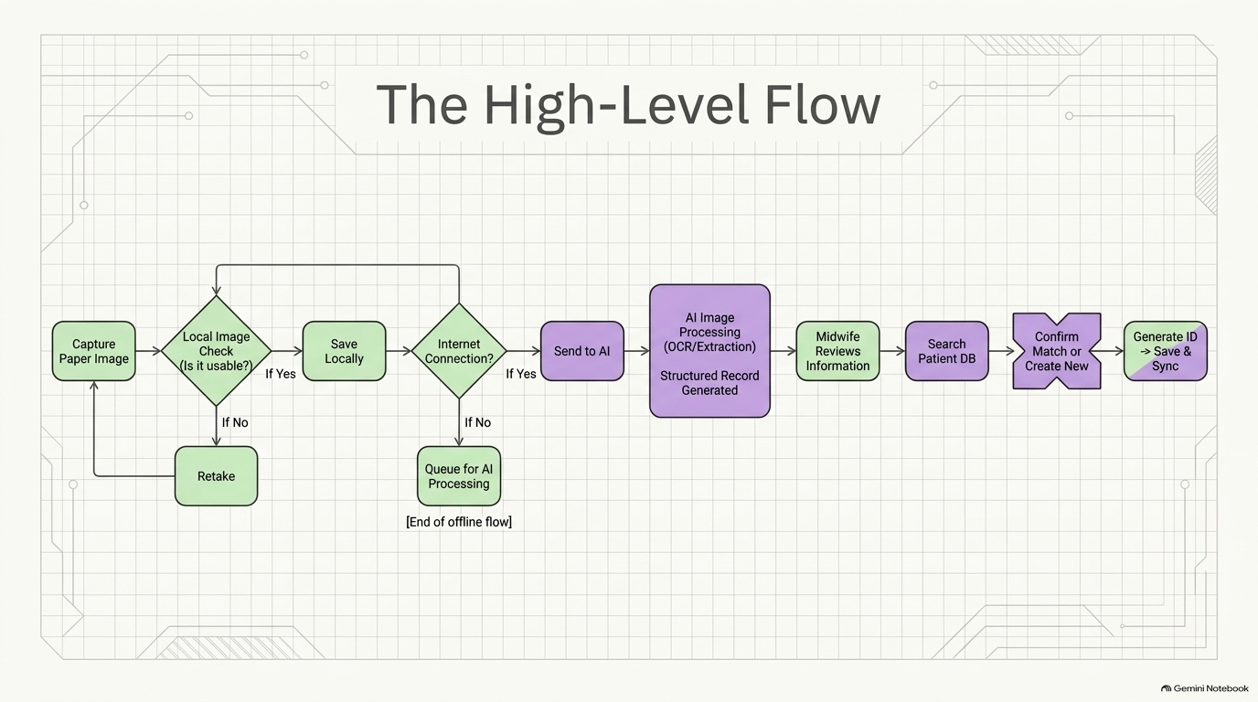

2. The chatbot is the interface
The chatbot acts as the conversational front end, while the underlying application handles:
- image capture
- OCR
- AI extraction
- patient matching
- database operations
- synchronization
- error handling.
For example:
Midwife
“I want to register a patient.”
Chatbot
“Please take a photo of the patient's paper registry.”
[Take photo]

Chatbot
“I received the image. I am extracting the information.”
Then:
“I found the following information. Please review it before I save it.”
Patient
- Name: Marie XXXXX
- Age: 27
- CIN: XXXXX
- Address: XXXXX
- Telephone: XXXXX
Pregnancy
- Gravidity: 3
- Parity: 2
- Expected delivery date: XXXXX
[Confirm] [Edit] [Retake photo]

3. Very important: offline vs. AI
Offline data collection, internet required for AI/sync
I would explicitly separate the system into two layers.
Layer 1 — Offline application
Must work without internet:
- Midwife login/session
- Camera
- Photograph capture
- Image storage
- Basic image-quality assessment
- Patient records already downloaded to the device
- Manual data entry
- Editing
- Local encrypted storage
- Queueing records for synchronization
Layer 2 — Online services
Require internet:
- AI/OCR processing
- Cloud database synchronization
- Potentially duplicate matching against the central database
- Backup
- Administrative functions
So if the midwife has no internet:
PHOTO
↓
STORE SECURELY ON DEVICE
↓
"Pending AI processing"
↓
MIDWIFE CAN CONTINUE WORKING
↓
INTERNET RETURNS
↓
UPLOAD
↓
AI PROCESSING
↓
REVIEW
↓
DATABASE SYNC
The app should never lose the captured record simply because the internet disappears.

4. What exactly gets digitized?
This is where the actual paper registry becomes very useful.
I would not tell the engineers to create a generic:
“OCR the document.”
Instead, we should create a document schema corresponding to the actual sections of the Cuadernito Rosa.
The system needs to recognize structured information from sections such as:
Patient identification
- Age
- CIN
- Education level
- Profession
- Address
- Telephone
- Husband's name
- Husband's profession
- Consanguinity
- Desired pregnancy
Medical/family history
- Hypertension
- Diabetes
- Hereditary diseases
- Malformations
- Allergies
- Other relevant history
Obstetric history
- Previous abortions
- Premature deliveries
- Intrauterine fetal deaths
- Previous deliveries
- Delivery dates
- Mode of delivery
- Cesarean indication
- Complications
- Newborn weight
- Other newborn complications
- Gravidity
- Parity
- Number of living children
Current pregnancy
The registry contains longitudinal antenatal information, including:
- Pregnancy dating
- Expected delivery date
- Gestational age
- Weight
- Blood pressure
- Clinical examination
- Fetal movements
- Fetal heart rate
- Urinalysis/laboratory information
- Treatment
- Follow-up visits
Delivery
The delivery page contains information such as:
- Place of delivery
- Date
- Mode of delivery
- Instrumental delivery
- Cesarean
- Complications
- Newborn status
- Sex
- Birth weight
- Head circumference
- Abnormalities
Postpartum/newborn
The later pages include:
- Postpartum timing
- Maternal condition
- Vital signs
- Lochia
- Perineal status
- Breast status
- Complications
- Medications
- Family planning
- Newborn age
- Temperature
- Weight
- Head circumference
- Breastfeeding
- Signs of serious illness
- Vaccination
- Malformations/complications
- Treatment
- Referral/follow-up

5. AI extraction should produce a structured object
The AI shouldn't simply return a block of text.
It should return something conceptually and importantly, each extracted field should have a status.
This allows the chatbot to say:
“I am not confident about the telephone number. Please verify it.” rather than silently putting incorrect information into the database.

6. Handling illegible information
I would change your original:
“Register in category as non available”
to a more technically precise requirement:
Every field must support an explicit missing-information state.
For example:
KNOWN
UNKNOWN
NOT_PROVIDED
ILLEGIBLE
NOT_APPLICABLE
NEEDS_REVIEW
This is better than simply storing "N/A".
For example:
Field | Value | Status
Name | Marie XXXXX | Confirmed
DOB | 12/04/1998 | Confirmed
Telephone | — | Illegible
Profession | — | Not provided
Cesarean history | — | Not applicable

7. Duplicate prevention
This should be one of the most important requirements.
The system should not automatically create a new patient merely because the name is different or missing.
When a new record arrives:
NEW INFORMATION
↓
SEARCH LOCAL PATIENT DATABASE
↓
SEARCH CENTRAL DATABASE WHEN ONLINE
↓
MATCHING ALGORITHM
↓
POSSIBLE PATIENTS
The chatbot might say:
“I found a possible existing patient.”
Then:
Patient 1
Marie XXXXX
Age: 27
Village: XXXXX
Patient 2
Mariam XXXXX
Age: 28
Village: XXXXX
The midwife decides.
Possible options:
[Patient 1]
[Patient 2]
[None — create new patient]
[I'm not sure]
The last option could flag the record for later review rather than forcing a decision.

8. Permanent patient ID
Your answer here is clear:
A permanent patient ID.
I recommend the system generate it automatically.
For example:
PAT-000001
PAT-000002
PAT-000003
The ID should not be derived from the patient's name.
And once assigned:
PAT-000184
│
├── Antenatal consultation 1
├── Antenatal consultation 2
├── Delivery
├── Postpartum consultation
└── Newborn information
That gives you a longitudinal record without duplicating the patient.

9. Original paper image
Every digitized registry retains its original image.
The database therefore has two related objects:
DIGITAL PATIENT RECORD + ORIGINAL PAPER DOCUMENT IMAGE
The original image should be associated with:
- Patient ID
- Consultation/record ID
- Date captured
- Midwife/user ID
- Processing status
- Possibly the original device ID
Access should be role-controlled.
The midwife should automatically have access to every patient's original document.

10. Recommended record lifecycle
CAPTURED
↓
PENDING_AI
↓
AI_PROCESSED
↓
NEEDS_REVIEW
↓
VALIDATED
↓
PATIENT_MATCHED
↓
REGISTERED
↓
SYNCED
There can also be:
PROCESSING_FAILED
SYNC_FAILED
DUPLICATE_SUSPECTED
MANUAL_REVIEW_REQUIRED
This will make troubleshooting much easier.

11. The chatbot should not hide system uncertainty
This is another requirement I would explicitly give the developers.
Bad:
“Patient registered successfully.”
when the AI was only 55% confident in the name.
Better:
“I extracted the patient's name, but the handwriting is unclear. Please verify it before I continue.”
And:
“I found two possible existing patients. Please select the correct patient or create a new record.”
The chatbot should make uncertainty visible rather than pretending the AI is certain.

12. What the Version 1 scope now looks like
I would define V1 as:
IN SCOPE
User
- Midwife
Interface
- Conversational chatbot
Input
- Photograph of paper maternal registry
Offline
- Patient data collection
- Image capture
- Local encrypted storage
- Queueing
Online
- AI/OCR
- Data extraction
- Synchronization
- Central database matching
AI
- Read paper registry
- Recognize handwriting/printed text
- Detect French/Arabic/English
- Map information to predefined fields
- Provide confidence/uncertainty
- Return structured data
Human verification
- Midwife reviews extracted information
- Midwife can edit
- Midwife confirms patient match
Patient registry
- Permanent patient ID
- Duplicate prevention
- Longitudinal record
Documents
- Original image retained
- Restricted access
Missing data
- Explicit unavailable/illegible states
OUT OF SCOPE FOR V1
- Maternal risk prediction
- Green/Yellow/Red triage
- Clinical decision support
- Diagnosis
- Treatment recommendations
- Automated medical recommendations

A. How is a patient initially identified?
Does the paper registry always contain a CIN (national identification number)?
If yes, is CIN intended to be the primary matching field?

B. What happens if there is no CIN?
For example:
Name + age + address + telephone
Should the app still create a patient ID?

C. Can one midwife see all patients?
Or should a midwife only see:
1. Her own patients
2. Patients at her health facility
3. All patients in the program
4. Something else
This determines the access-control architecture.

D. Is there one paper registry per patient?
Or could the midwife photograph multiple pages of the same Cuadernito Rosa during one digitization session?
I suspect the answer is the latter, and if so the workflow should be:
Start digitization
↓
Page 1
↓
Page 2
↓
Page 3
↓
...
↓
Page 6
↓
Process entire document
rather than treating every photograph as a separate record.

E. What happens if the midwife has already digitized this patient?
For example, she photographs the same Cuadernito Rosa again two months later.
Should the system:
A. Add only the new information
B. Replace the previous record
C. Show the existing record and let the midwife choose what to update
I strongly recommend C.

F. Should the original French information remain visible?
For example, the paper says:
Nom du Mari
Should the digital interface display:
Husband's name
while preserving the original French terminology/document image?
Or do you want the chatbot itself to operate in French, English, or both?

G. What happens when the AI cannot process the document?
For example, no internet for two days, or the handwriting is too difficult.
Should the midwife be able to manually enter the information into the chatbot/app, so the patient can still be registered?
I would recommend yes.

H. One architectural question: is the chatbot allowed to ask follow-up questions?
For example:
Chatbot: “I cannot read the patient's date of birth. Do you want to enter it manually?”
Midwife: “Yes.”
Chatbot: “What is the date of birth?”
This is what I would expect from your description of the chatbot as the interface, but I want to confirm it.

